Frequency and distribution of ratings for the Friends and Family Test question

How likely are you to recommend our GP practice to friends and family if they needed similar care or treatment?

Table 1

Criteria category for scoring | Response scale | Number of responses | Percentage of responses*
Promoters | Extremely likely | 34 | 68%
Passive | Likely | 14 | 28%
Detractors | Neither likely nor unlikely | 1 | 2%
 | Unlikely | 0 | 0%
 | Extremely unlikely | 1 | 2%
 | Don't know | 0 | 0%
Total responses to this question |  | 50 | 100%
* May not add up to 100% due to rounding

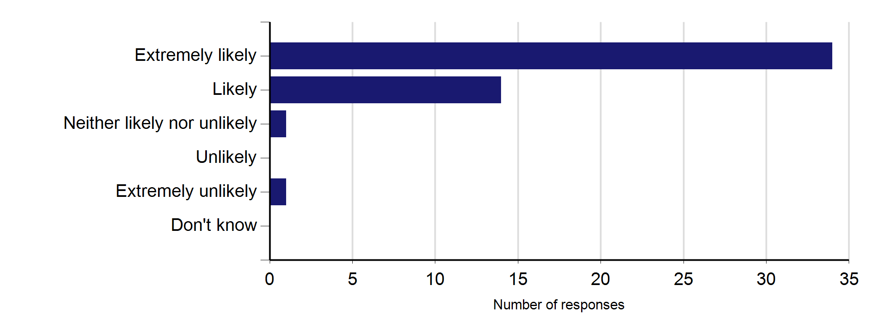
Graph 1

96% of patients who responded to the survey would be either extremely likely or likely to recommend your practice to friends and family if they needed similar care or treatment.
The sum of the 'Extremely likely' and 'Likely' percentage of responses in Table 1 may not equal the percentage in the grey box above due to rounding.

Of those 50 patients who answered the Friends and Family Test question, 49 (98%), filled out a paper questionnaire and 1 (2%), completed a questionnaire online.

Cumulative and previous survey information Table 2
Frequency and distribution of ratings
Extremely likely | Likely | Neither likely nor unlikely | Unlikely | Extremely unlikely | Don't know

 | Total responses to Q1 | Percentage of patients extremely likely or likely to recommend
Cumulative feedback* | 561 | 92%

372 | 145 | 15 | 7 | 10 | 12

*This cumulative feedback is based on the sum of the previous months survey data, as below (up to a maximum of 12 months).
Jul-16 | 50 | 96%
Jun-16 | 46 | 96%
May-16 | 48 | 92%
Apr-16 | 45 | 98%
Mar-16 | 48 | 92%
Feb-16 | 48 | 90%
Jan-16 | 48 | 90%
Dec-15 | 46 | 93%
Nov-15 | 48 | 92%
Oct-15 | 46 | 89%
Sep-15 | 40 | 88%
Aug-15 | 48 | 92%

34 | 14 | 1 | 0 | 1 | 0
29 | 15 | 1 | 1 | 0 | 0
28 | 16 | 0 | 2 | 2 | 0
36 | 8 | 0 | 1 | 0 | 0
36 | 8 | 2 | 1 | 1 | 0
31 | 12 | 3 | 0 | 0 | 2
31 | 12 | 2 | 0 | 1 | 2
33 | 10 | 0 | 0 | 0 | 3
32 | 12 | 0 | 1 | 1 | 2
32 | 9 | 1 | 0 | 2 | 2
21 | 14 | 4 | 0 | 1 | 0
29 | 15 | 1 | 1 | 1 | 1

Patient comments The following comments are from patients who indicated that they were happy for these to be made public.
All comments are included in their entirety but all attempts have been made to remove details which could identify specific patients or practitioners.

Please tell us why you answered as you did in question 1:
- The walking appointment system enables patients to be seen on the very day they are ill and by the doctor of their choice. No having to make appointments way in the future nor repeatedly telephoning in the hope someone answers. Staff are courteous and helpful and the doctors outstanding.
- I have been coming here many years and feel very confident with my doctor. He has treated me with compassion and light medication. I would not change my doctor.
- No appointments.
- Everything.
- Wonderful staff and caring doctors.
- Because the GP is proactive in looking after their clients.
- All doctors and staff cooperative and helpful.
- I like that it is a drop in service. However feel the appointments are quite rush with some doctors and various creams/treatments given have not always worked and had to come back again.
- You do not spend a lot of time here and the staffs are very friendly.
- I have always been treated extremely well and I would be ready to recommend this practice to my friends and family.
- You don't book to see the doctor and swift attendance.

Please tell us why you answered as you did in question 1:
- One of the doctors provides information in timely fashion within NHS guidelines. Always willing to listen and give most relevant advice. Staff are friendly, efficient and polite.
- Because I feel good after my treatment.
- Because this GP is the best GP.
- Drop in surgery gives flexibility so you or your child can be seen when needed. The doctor takes on board any concerns and gives referrals if required.
- Because I don't have to make an appointment to see my GP. Staffs are helpful too.
- Staff is good.
- Because we get attended to as soon as possible. Very friendly people at the surgery.
- Very professional and friendly atmosphere. Very caring, I am in good hands. Like feeling.
- Always helpful.
- Staff are always polite, take time out to listen to you, very helpful. Waiting times are normally very good.
- Because it is an open surgery no appointment. To crown it all it is efficient and responsibility to customer service standard and everyday surgery to suit everyone's need.
- The doctor always very good. Look after me and very helpful.
- I am attending the surgery many years. Doctors are very polite and caring. Staff also polite, service with smile.
- Because of my experience.
- Good clinicians. It is also open on Saturdays. Good referral process. Polite admin staff. Great with children. Flexible hours. Good repeated prescription process.
- No appointments needed.
- I'm happy with the service they provided.
- As it is an open day surgery. No appointments. Also the doctors listen to patients problems and the receptionists are also very helpful.
- Good service and a lot of information.
- I have been coming to this surgery for the last many years and will continue to do so till I die. This is an indication that I am happy with the service I get and more importantly the treatment and attention. The staff are warm and friendly.
- My GP has time for his patients. He carefully assess me with questions and makes or prescribes the right medication to me. With my repeat prescription, he sends it online.
- Two of the doctors are efficient, caring and provide relevant information. Doctors are willing to listen and impart advice.
- Good service.
- Because an appointment is not necessary. Just turn up if something is wrong.
- Because the waiting time for appointments is very short, you could see a doctor the same day.

Demographics

Q3: Gender

 | Number of responses | Percentage of responses*
Male | 20 | 40%
Female | 27 | 54%
Blank | 3 | 6%
* May not add up to 100% due to rounding

Q4: Age

 | Number of responses | Percentage of responses*
0 - 15 | 0 | 0%
16 - 24 | 3 | 6%
25 - 34 | 9 | 18%
35 - 44 | 10 | 20%
45 - 54 | 9 | 18%
55 - 64 | 10 | 20%
65 - 74 | 5 | 10%
75 - 84 | 4 | 8%
85+ | 0 | 0%
Blank | 0 | 0%
* May not add up to 100% due to rounding

Q5: Ethnic group

 | Number of responses | Percentage of responses*
White | 9 | 18%
Mixed/Multiple ethnic groups | 0 | 0%
Asian/Asian British | 28 | 56%
Black/African/Caribbean/ Black British | 12 | 24%
Other ethnic group | 0 | 0%
Blank | 1 | 2%
* May not add up to 100% due to rounding

Q6: Day-to-day activities limited because of health?

 | Number of responses | Percentage of responses*
Yes, limited a lot | 3 | 6%
Yes, limited a little | 9 | 18%
No | 35 | 70%
Prefer not say | 1 | 2%
Blank | 2 | 4%
* May not add up to 100% due to rounding

Supporting documents

Additional information on the Friends and Family Test

The Friends and Family Test (FFT) is a feedback tool that supports the fundamental principle that people who use NHS services should have the opportunity to provide feedback on their experience that can be used to improve services. It is not a traditional survey. It is a continuous feedback loop between patients and practices.

Practices can use the feedback gathered through the FFT to celebrate successes and to support staff to make improvements where the experience of service does not live up to expectations. FFT results are also one useful source of information which can help to inform choice for patients and the public.

More information and guidance about the use of the FFT in the NHS can be found at http://offlinehbpl.hbpl.co.uk/NewsAttachments/PGH/FFT.pdf and http://www.england.nhs.uk/wp- content/uploads/2014/07/fft-imp-guid-14.pdf.

